**Library Management System**

Sayed Tahsinoor Rahman (C191101)  
Mohammad Fahad Faisal(C191085)

Emon Dhar(C191089)

**International Islamic University Chittagong**

Submitted to:

**Mr. Shahidul Islam Khan**

Associate Professor

Department of CSE, IIUC

Course Title: Database Management Systems Lab

Course code: CSE-2424

Database Final Project Report

# Table of Contents

1. Introduction

1.1 Description……………………………………………………….4

1.2 Conecptional Model…………………………………….............5

1.3 Features……………………………………………....................6

2.0 DDL and DML

2.1 Create table……………………………………………………8

2.2 Insert data……………………………..…………...................11

2.3 Update…….………………………………………….............13

2.4 Select…………………………………………………………15

3.0 Join Statement

3.1 Inner join…………………………………………..................17

3.2 Right outer join………………………………….…………...19

3.3 Left outer join……………………………………...................21

4.0 E-R Diagram …………………………………………………...23

# Figure’s List

1. Conceptional model
2. Login and Main Menu
3. Student Table
4. Book Table
5. Issue Table
6. Add new Student
7. Add new Book
8. Issue Book
9. Return Book
10. Show Student’s info
11. Show Book’s info
12. Statistics
13. Inner Join
14. Show Student’s Status
15. Right Outer join
16. Show Book’s Status
17. Left Outer Join
18. ER Diagram

1.0 **Introduction**:

**1.1 Description:**

A simple Library Management System which allows us to add new Students, add new books, issue books to specific students and return books. Also, we can check activity of borrowing books and returning books. And we can search students information by their ID, Name, course and department. Also, we can search for books by its ID, Name, Publisher, price and Published Year. We can get the transaction log of borrowing books and returning books of Specific student and specific book. We used java with NetBeans and ORACLE Database for the project. Here we used Three Table **STUDENT**, **BOOK**, **ISSUE** where we can see student information, book information and Issue booklist. We used **INSERT**, **CREATE**, **UPDATE**, **SELECT**, **INNER JOIN, LEFT OUTER JOIN, RIGHT OUTER JOIN** in various ways and also in used some **SUB-QUERY**.

**1.2 Conceptional Model:**

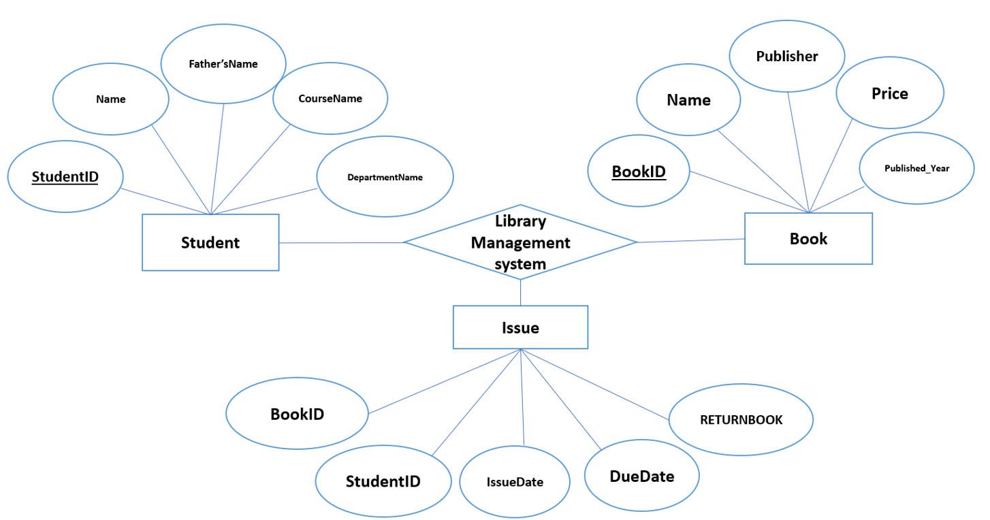

**Figure: Conceptional Model.**

**1.3 Features**:

After login into the software here we used 10 features.

**1.New Students:** Adds new students into STUDENTS database Table by inserting students information like ID, Name, Father’s name, Course name, Department name.

**2.New Books:** Adds new books into BOOKS database Table by inserting books information like Book ID, Name , Publisher, Price , Publish year.

**3.Statistics:** It has two different table view. One is Issue table where we can see the student list along with those books that is borrowed. Another one is Return book where we can see those booklist which have been returned by students.

**4.Return Books:** Students can return borrowed books by using this feature. After submitting book ID and Student id student can check whether the book is borrowed or not. If it is borrowed the student can return the book.

**5.Iusse Books:** Students can borrow books by using Issue book feature. By inserting Book id and student id any student can borrow books.

**6.Student info:** Here we can search student’s information by searching any of the students information like ID, NAME, Course Name, Department Name.

**7.Student Status:** We can see a table of a specific student where it shows the list of books that is borrowed , Issue date , Due date and the book is Returned or not.

**8.Book info:** We can search for any Books by searching any of the books category like ID, Name, Publisher, Price, Publisher year. Also here we add a feature named **All Book List** which shows a list of all books which are registered in our library.

**9.Book Status:** We can get the transaction log of borrowing books and returning books of Specific Books by searching book ID.

**10.Logout**: Logout from software

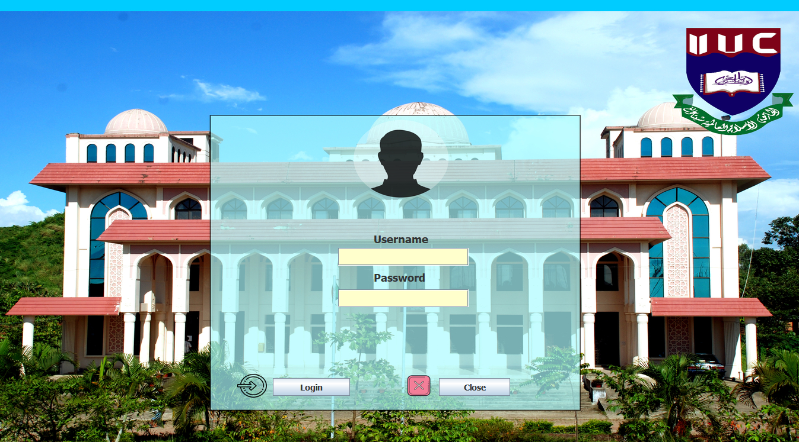

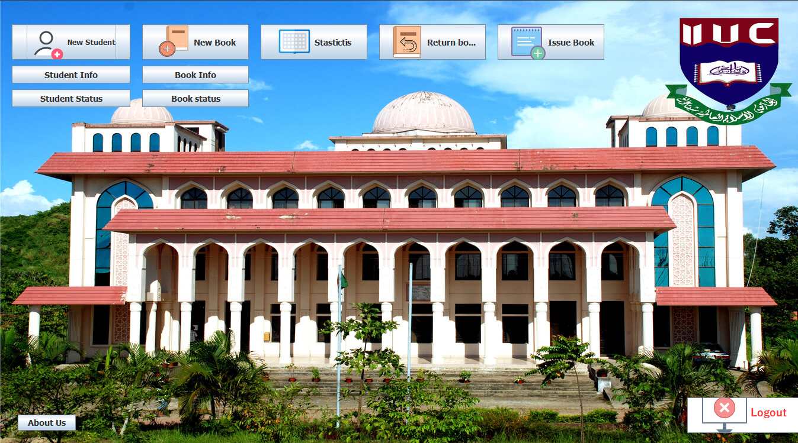

**Figure: Login & Main Menu**

**2.0 DDL and DML**

**2.1 Create Table:**

**Student Table:**

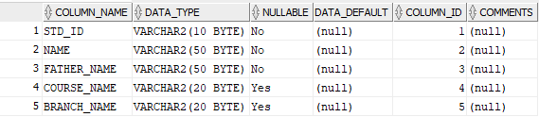

**Figure: Student Table**

**CREATE statement for STUDENT Table**

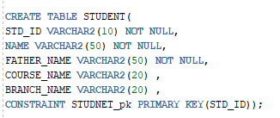

**Book Table:**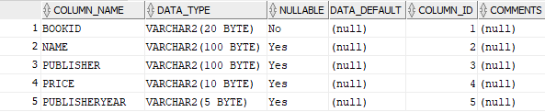

**Figure: Book Table**

**CREATE statement for BOOK Table**

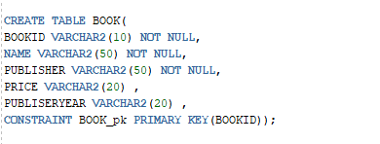

**Issue Table:**

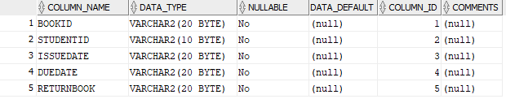

**Figure: Issue Table**

**CREATE statement for ISSUE Table**

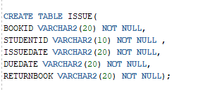

**2.2 Insert Data:**

**Add new Student**

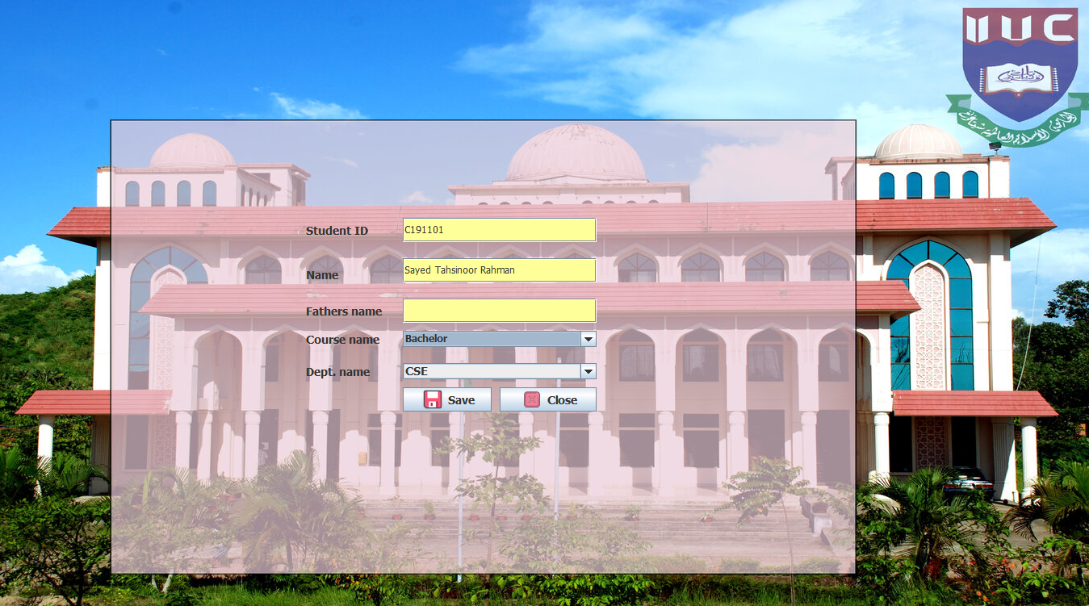

**Figure: Add Student**

**INSERTING values in STUDENT Table**

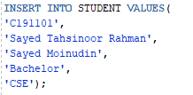

**Add new Book**

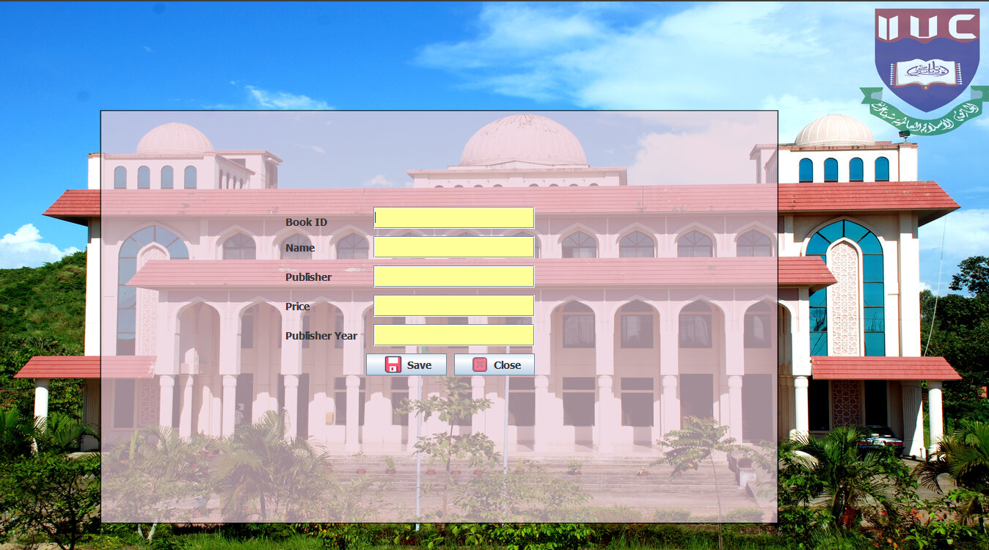

**Figure :Add new Book**

**INSERTING values in BOOK Table**

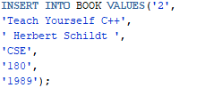

**Issue a Book to specific Student**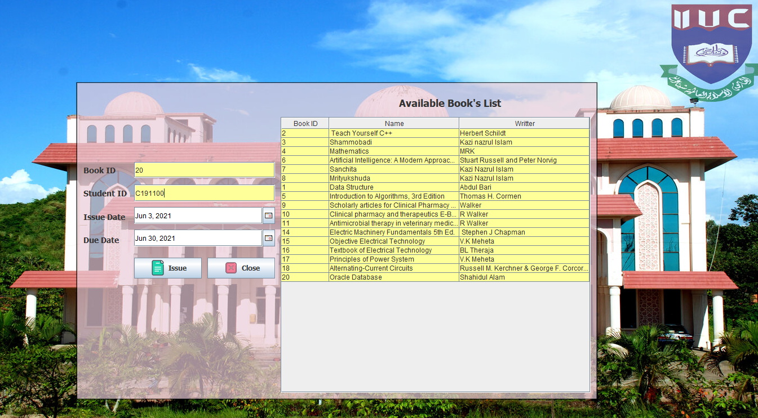

**Figure :Issue Book**

**Here first we will show a list of availabe book**

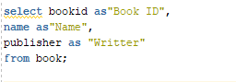

**Then we will insert some value into our ISSUE Table**

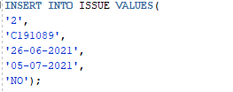

**2.3 Update:**

**Return Book**

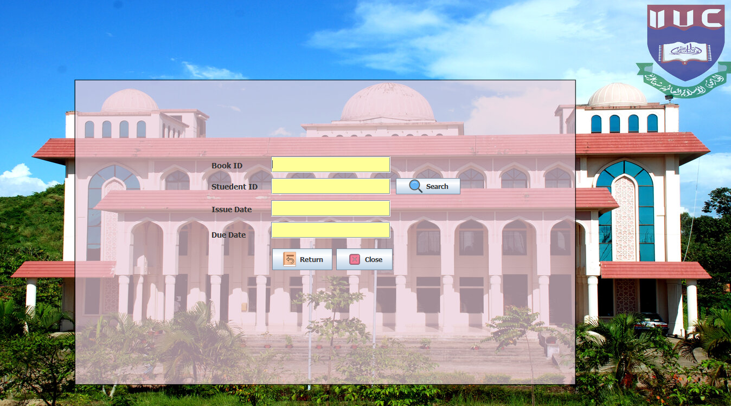

**Figure: Return Book**

After getting **bookid** and **studentid** we look through the **ISSUE** Table for that **bookid** and **studentid** which has not returned the book yet.

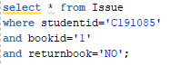

Then **UPDATE** the **returnbook** column to **YES**.

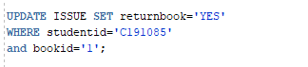

**2.4 Select:**

**Showing Student Info**

Here we can search students by **ID , NAME , COURSE , DEPARTMENT**

Also we can see All students list.

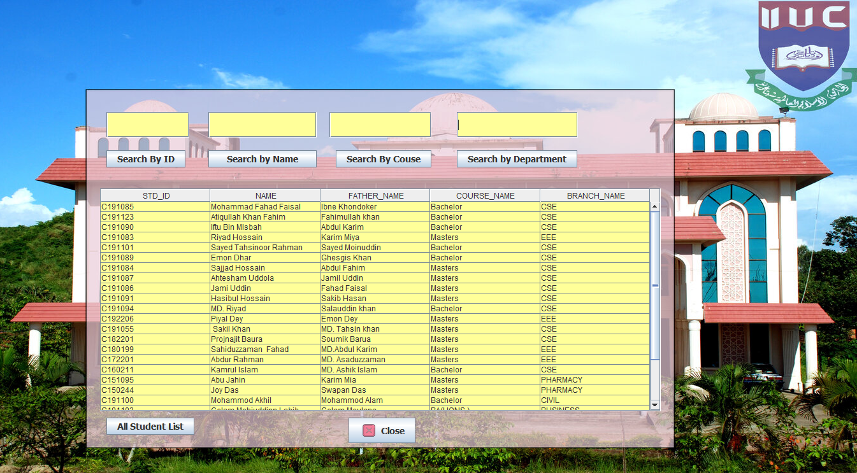

**Figure: Showing Student info**

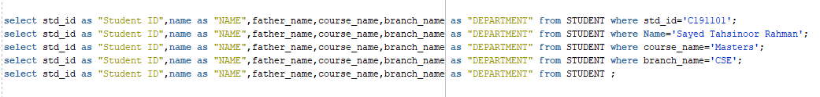

**Showing BOOK Info**

Here we can search books by **ID , NAME , PUBLISHER , PRICE , PUBLISHED_YEAR**

Also we can see All books list.

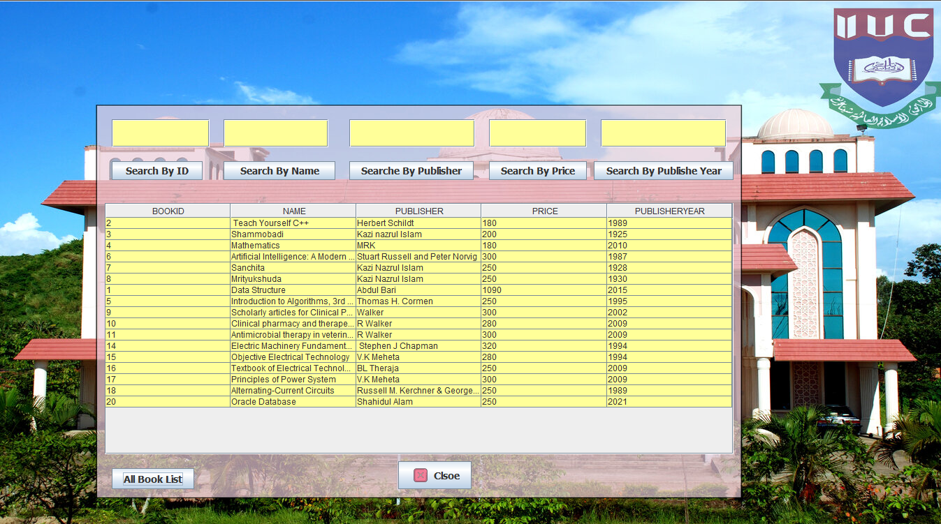

**Figure: Showing Book Info**

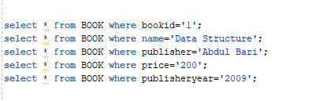

**3.0 Join Statement:**

**3.1 Inner Join:**

**Statistics of Book issue and Return**

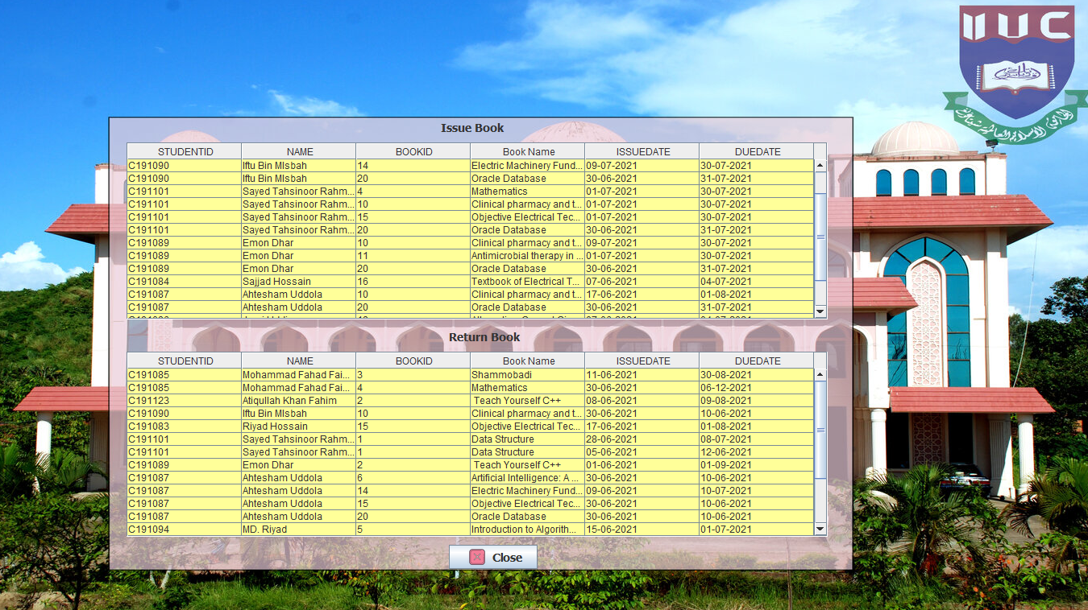

**Figure: Statistics**

In the Issue book table, we **INNER JOINe**d three table **STUDENT BOOK ISSUE**

With **bookid** and **studentid** where book has not returned yet.

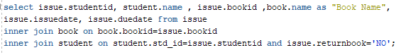

In the Return book table, we **INNER JOINe**d three table **STUDENT BOOK ISSUE**

With **bookid** and **studentid** where book has been Returned.

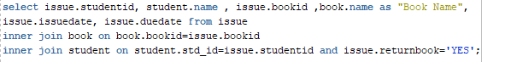

**INNER JOIN**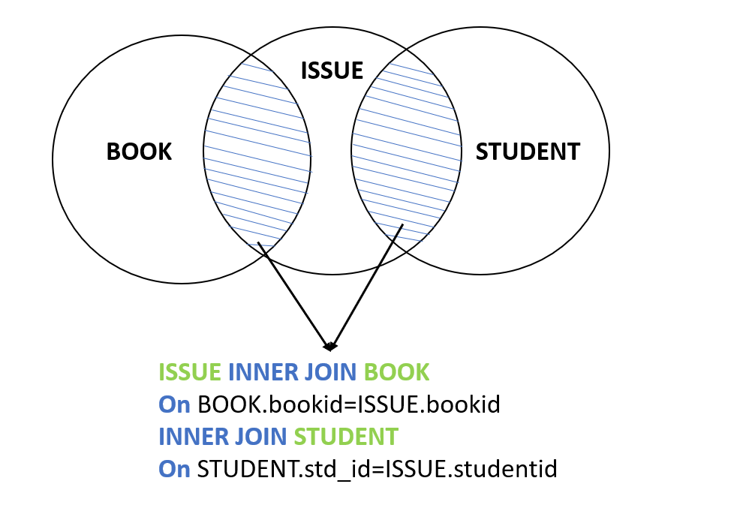

**Figure: Inner Join**

**3.2 Right Outer Join:**

**Showing student’s status**

Here we can see the activity of borrowing and return books of a specific student by **RIGHT OUTER JOIN** ISSUE and STUDENT table.

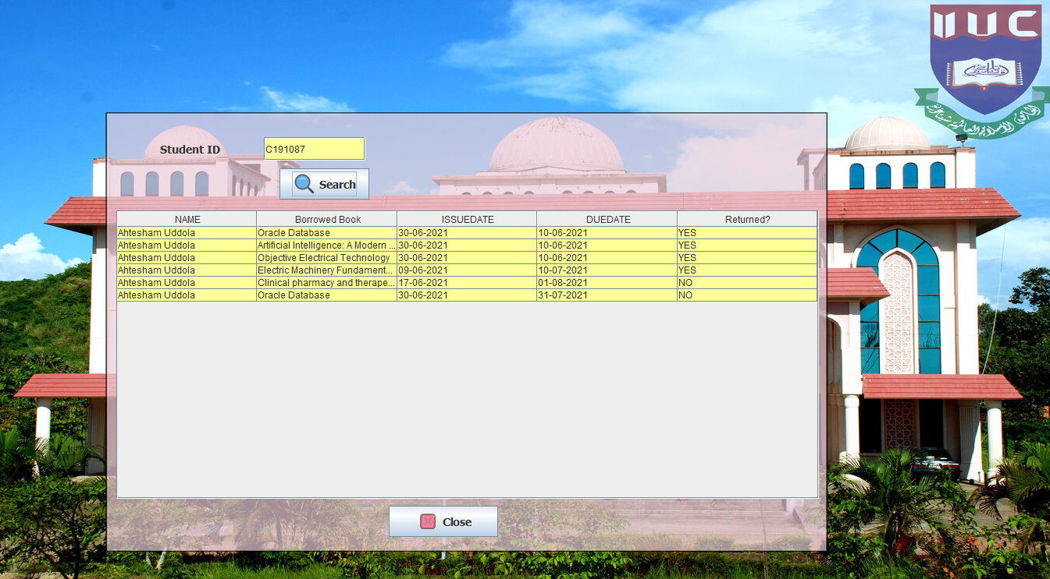

**Figure: Showing student status**

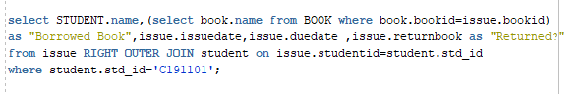

**RIGHT OUTER JOIN**

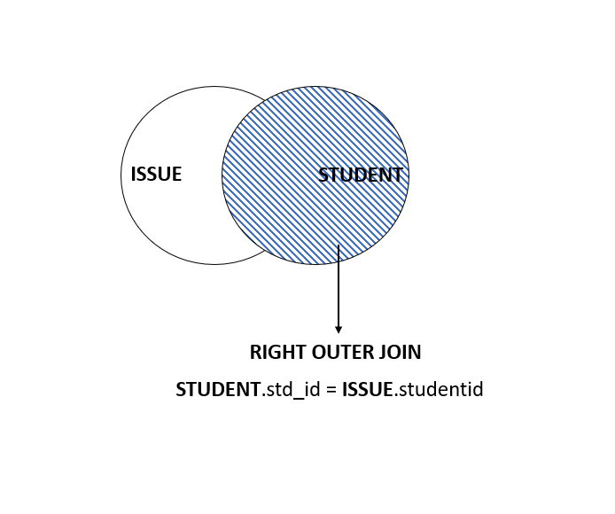

**Figure: Right Outer join**

**2.3 Left Outer Join:**

**Showing BOOK status**

Here we can see the activity of borrowing and return books of a specific book by **LEFT OUTER JOIN** BOOK and ISSUE table.

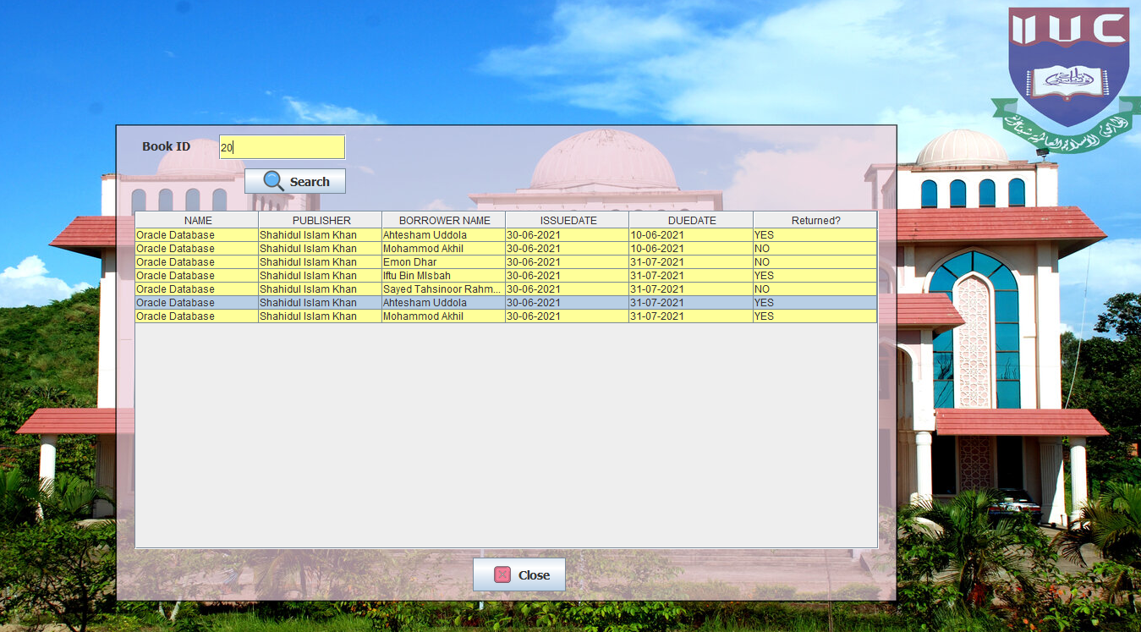

**Figure: Showing Book Status**

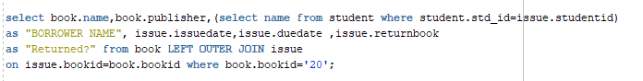

**LEFT OUTER JOIN**

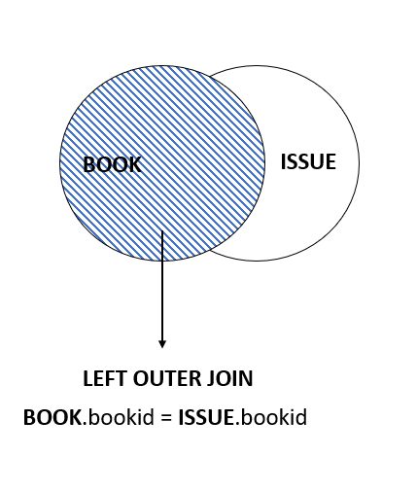

**Figure: Left Outer Join**

**4.0 E-R Diagram**

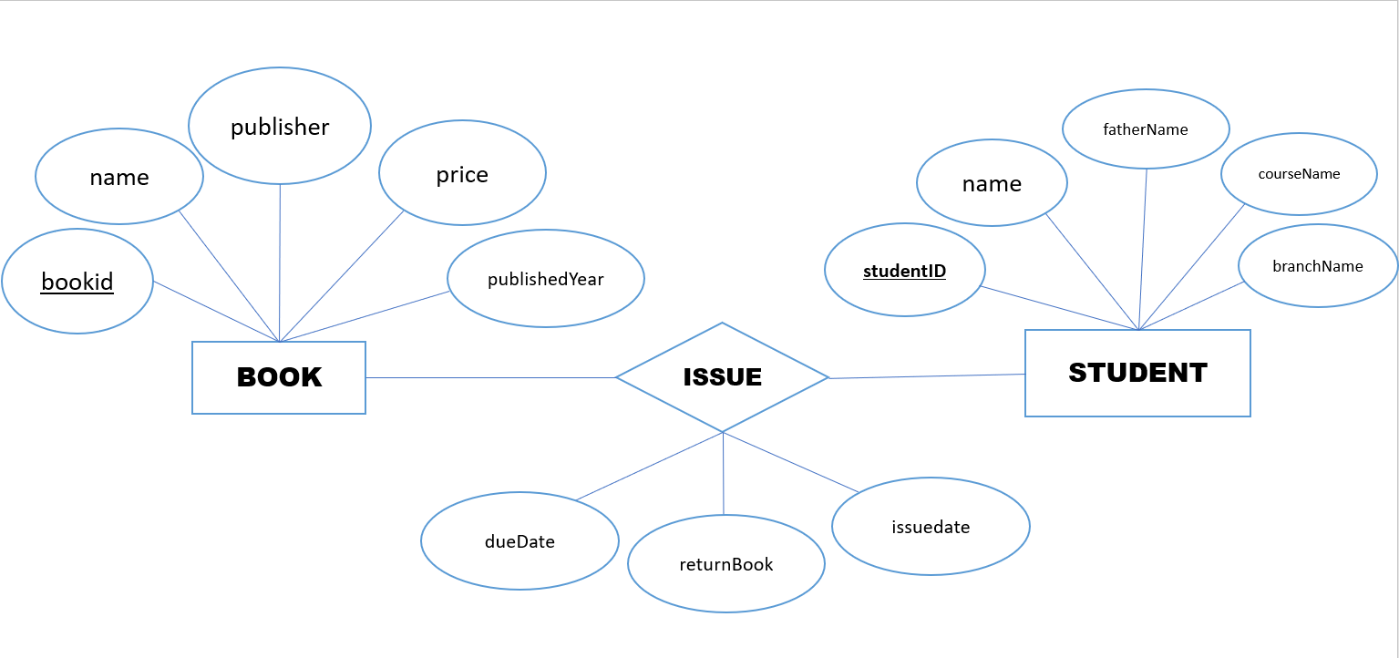

**Figure: E-R Diagram**